**NAME: S.Ajay kumar reddy**

**REG.NO.:192211480**

**EXPERIMENT: 11**

**AIM:** To implement the BIT SUFFERING MECHANIS using C language.

**ALGORITHM:**

Here's an algorithm for bit stuffing:

1. Define the special bit pattern to be used for flagging the beginning and end of a frame. This could be any sequence of bits, but commonly used patterns include 01111110 or 11111111.
2. Scan the data to be transmitted, and for each occurrence of the special bit pattern, insert an extra 0 bit after the fifth consecutive 1 bit.
3. Add the flag bit pattern at the beginning and end of the frame to indicate the start and end of the frame.
4. Transmit the frame over the communication channel.
5. At the receiving end, scan the received data for the flag pattern and remove any stuffed 0 bits that were added during transmission.
6. Process the remaining data as normal.

The bit stuffing algorithm ensures that the receiver can correctly interpret the data even if the special bit pattern occurs within the data. By adding extra bits to the data during transmission, the receiver can easily identify the start and end of each frame, and correctly interpret the data contained within.

**PROGRAM:**

# include<stdio.h>

#include<string.h>

int main()

{

int a[20],b[30],i,j,k,count,n;

printf("Enter frame size (Example: 8):");

scanf("%d",&n);

printf("Enter the frame in the form of 0 and 1 :");

for(i=0; i<n; i++)

scanf("%d",&a[i]);

i=0;

count=1;

j=0;

while(i<n)

{

if(a[i]==1)

{

b[j]=a[i];

for(k=i+1; a[k]==1 && k<n && count<5; k++)

{

j++;

b[j]=a[k];

count++;

if(count==5)

{

j++;

b[j]=0;

}

i=k;

}

}

else

{

b[j]=a[i];

}

i++;

j++;

}

printf("After Bit Stuffing :");

for(i=0; i<j; i++)

printf("%d",b[i]);

return 0;

}

**OUTPUT:**

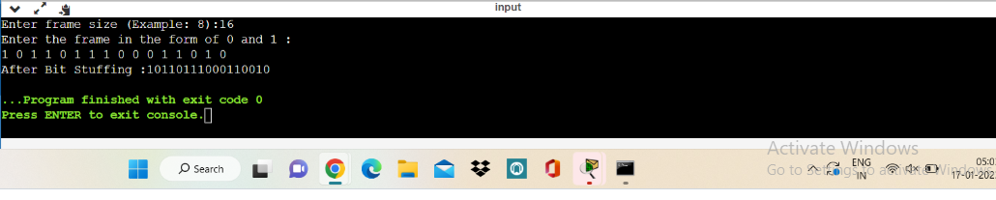

**RESULT :**

Therefore BIT SUFFERING MECHANISM has been successfully implemented using c program.